**TypeScript - did you know?**

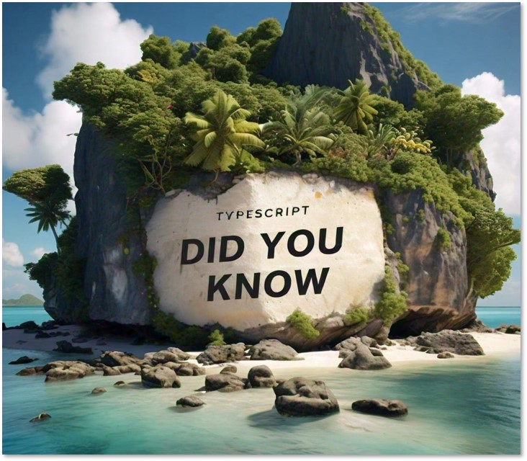

* To convert TypeScript code into JavaScript, you need a compiler of some sorts
* The most widely used tool for this purpose is the official TypeScript compiler, known as **tsc**
* TypeScript have also developed the TypeScript Compiler API, that allows other environments (libraries and servers like Deno and Node) to provide their own mechanisms for transpiling TypeScript
* This flexibility enables developers to adapt the TS compiler to suit their specific needs